[sprinkle cake](https://web.archive.org/web/20240122072216/https:/mynameisyeh.com/mynameisyeh/2014/9/funfetti-cake)

[**09 . 9 . 14**](https://web.archive.org/web/20240122072216/https:/mynameisyeh.com/mynameisyeh/2014/9/funfetti-cake)

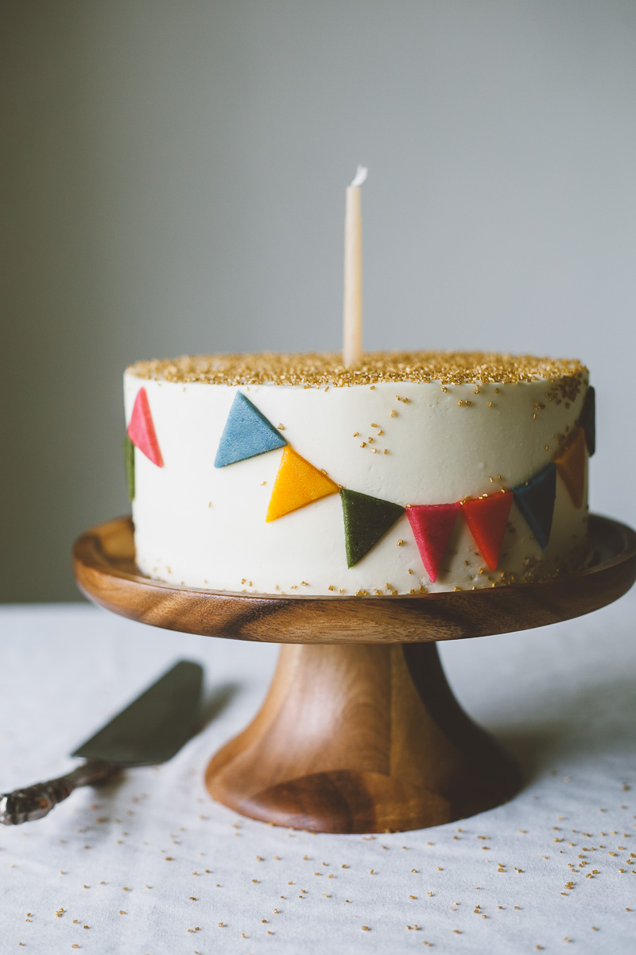

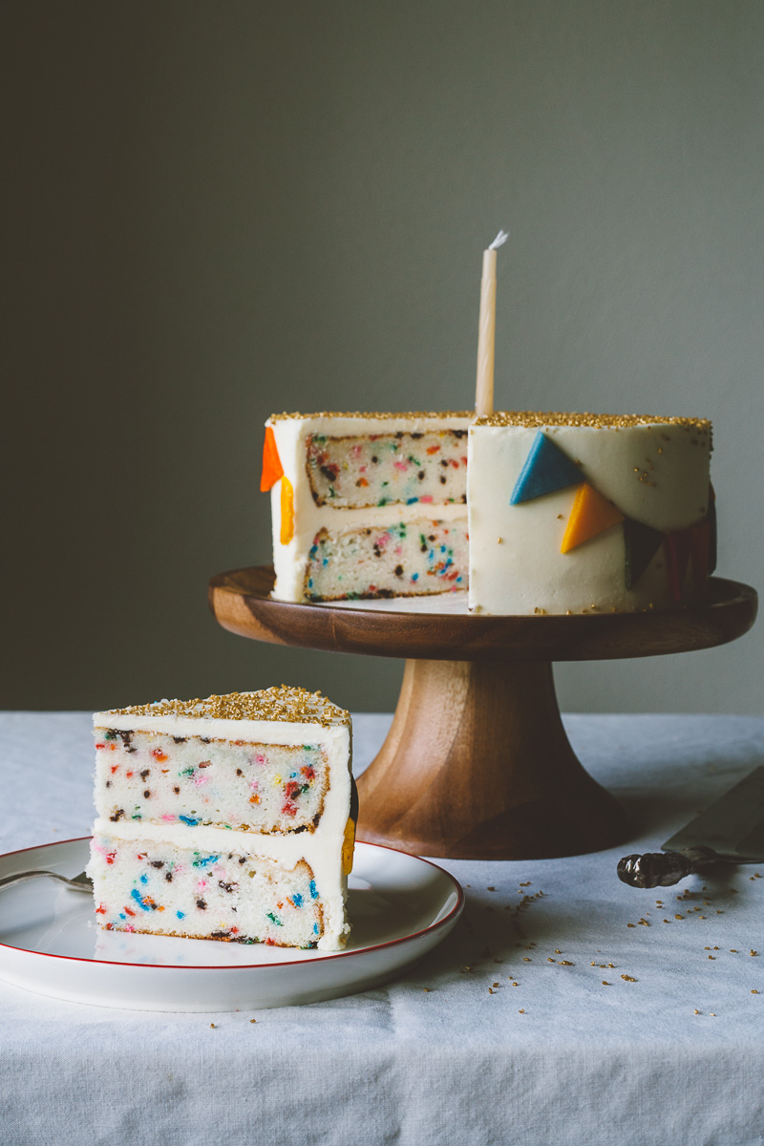

not the possibility of my wedding dress being too tight after eating too many cheesy toasts, not the unidentified dot on my face that i'm pretty sure is housing a 100-foot ingrown hair, not the upcoming beet harvest that will have eggboy working 27 hours a day. no. the thing that has kept me up at night these past two months has been: a homemade version of funfetti® cake.

*it's just sprinkles in white cake.*

*it's just sprinkles in white cake.*

it's not just sprinkles in white cake.

**attempt number one:**

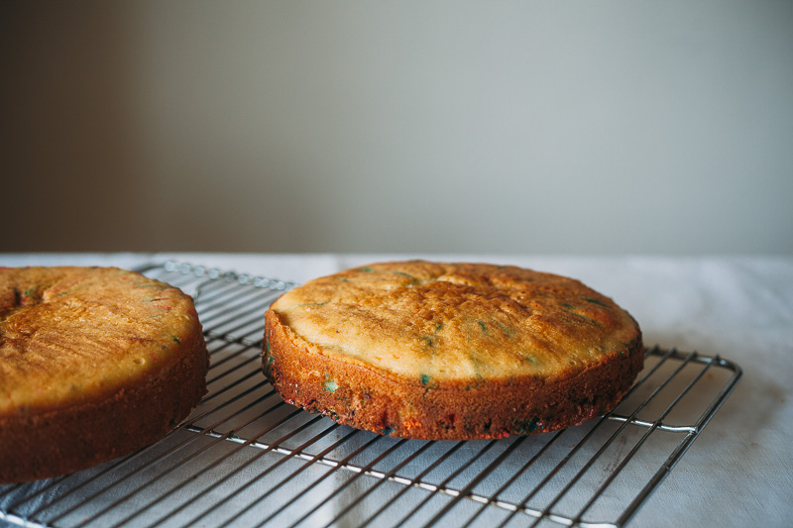

i began with the[**number one rule of anything funfetti®-inspired**](https://web.archive.org/web/20240122072216/http:/mynameisyeh.com/mynameisyeh/2014/8/funfetti-biscotti)[**desserts**](https://web.archive.org/web/20240122072216/http:/mynameisyeh.com/mynameisyeh/2014/8/funfetti-biscotti),which i picked up from [**marian**](https://web.archive.org/web/20240122072216/https:/food52.com/users/84231-marian-bull)**,** who learned it from a momofuku milk bar class: use clear imitation vanilla. that is the flavor that will launch you right back into a babysitters' club slumber party world, complete with scrunchies and friendship bracelets.

i combined this knowledge with my go-to vanilla cake, which is based on [**these gorgeous cupcakes**](https://web.archive.org/web/20240122072216/http:/www.pastryaffair.com/blog/vanilla-cupcakes.html)**.**it draws its moisture from butter and oil, and gets a slight zing from yogurt. i folded in a heavy dose of sprinkles, thinking my job was pretty much done.

and the end product was fine, just fine. i would have been happy to serve it to my mother and we would have enjoyed it a bunch.

*however.*

it could have been sprinklier, the colors could have popped more, the sprinkles could have been scattered more evenly, and the texture could have been closer to the original (lighter). all of these things kept me from *saying yes.*

i also wanted to know what other colorful objects might work.

**sprinkle testing:**

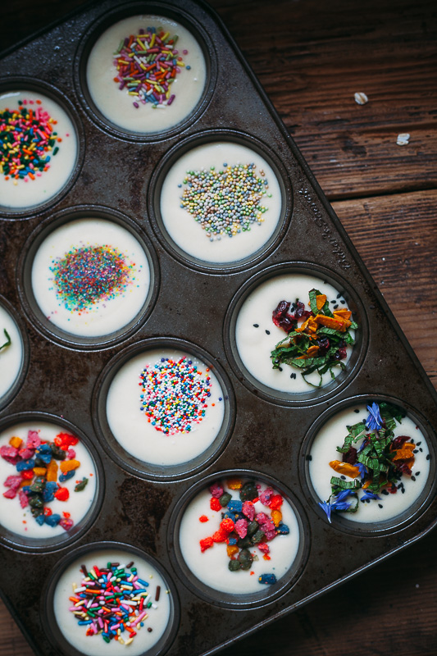

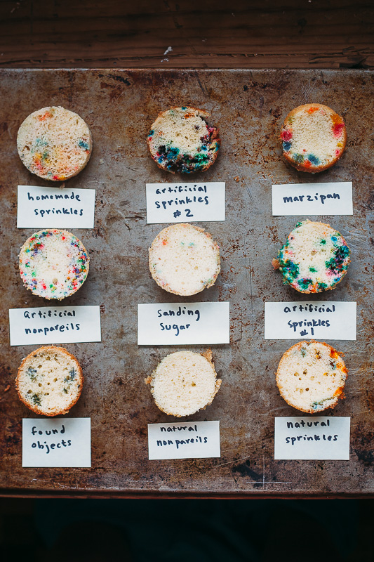

here are sample cakes with all of the sprinkles i own, as well as chopped colored marzipan and a series of found objects, including fresh mint leaves, petals of bachelor button flowers, black sesame seeds, chopped dried cranberries, and chopped dried mango. it's clear which sprinkles held onto their colors throughout the baking process. and one more thing is clear: it's very important to fold those suckers in thoroughly (*see: the clumps in the artificial sprinkle samples*), as in, it's probably best to fold them in *before* you pour the batter into the pan so you can have more room in the bowl to make sure you do a thorough job. the cake with the found objects, which i was really excited about, didn't look too terrible up close, it just tasted weird with all of that fresh mint. sadly, none of the natural sprinkles worked very well (i really didn't want to believe that the 2.9 pounds of naturally dyed sprinkles i just bought wouldn't work, but despite *numerous* attempts, they wouldn't), and the sanding sugar dissolved. so i narrowed my favorites down to four choices and then baked full layers with them, adding more sprinkles than the first test, and being careful to fold them in thoroughly:

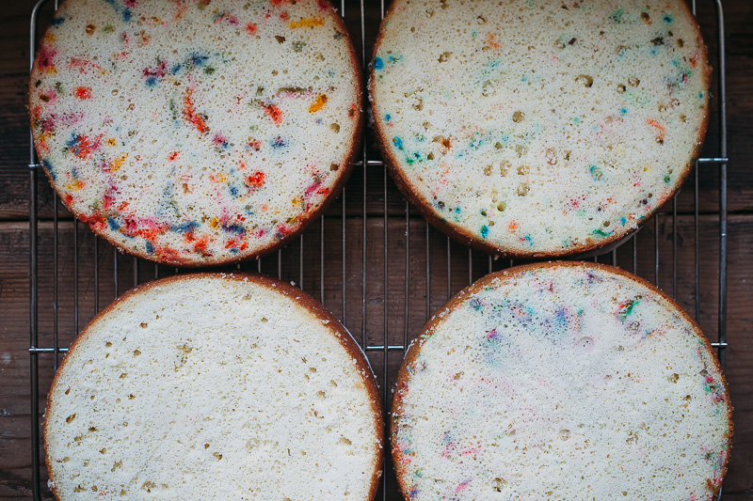

top: artificially dyed homemade sprinkles on the left, artificially dyed store-bought sprinkles on the right; bottom: artificially dyed marzipan on the left, artificially dyed nonpareils on the right.

and here they are all stacked up for**attempt number two-ish:**

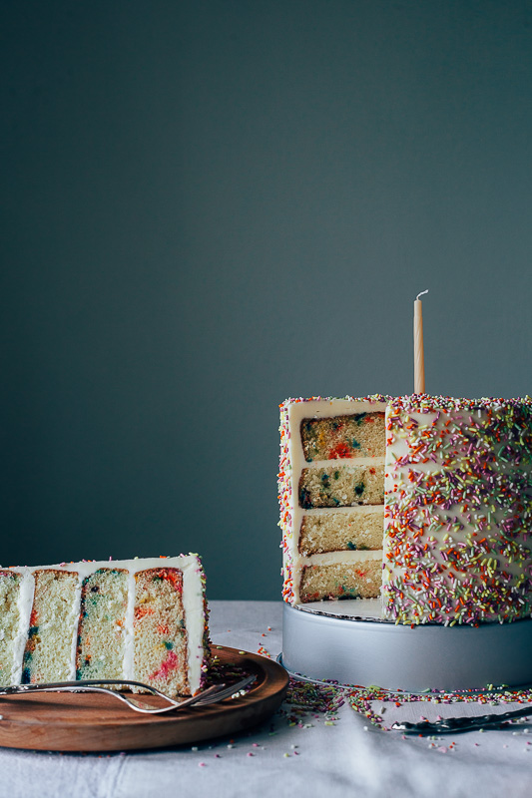

the layers are, from bottom to top: store-bought sprinkles, marzipan, nonpareils, and homemade sprinkles. many of the sprinkles fell right to the bottom and still the colors didn't pop too well. also, eggboy thought that decorating the cake with sprinkles on the outside took away from the sprinkles on the inside. three points, eggboy!

ok so what did i learn from this step?

the sprinkles need to be suspended in thicker batter and the batter needs to be whiter. how do we make a batter whiter? eliminate egg yolks. how do we make a batter thicker? with the help of john the baker from the town bakery, i learned three ways: use a higher protein flour (cake flour has a low protein percentage, so perhaps sub some of it for all-purpose flour), use less liquid ingredients and more solid ingredients (butter instead of oil, for example), whip the egg whites to peaks before folding them in with the rest of the ingredients.

my next cake used 1 cup of all-purpose flour and 1 1/2 cups of cake flour, as well as more butter, less oil, and no yogurt. eliminating the acidic ingredient yogurt eliminated the need for baking soda. i also sprinkled some sprinkles on top of the batter after pouring it into my cake pans, to make sure there were sprinkles towards the top of the layers (i picked this up from reading momofuku milk bar's birthday cake recipe).

**attempt number three (part ap flour + part cake flour), in the style of pacman:**

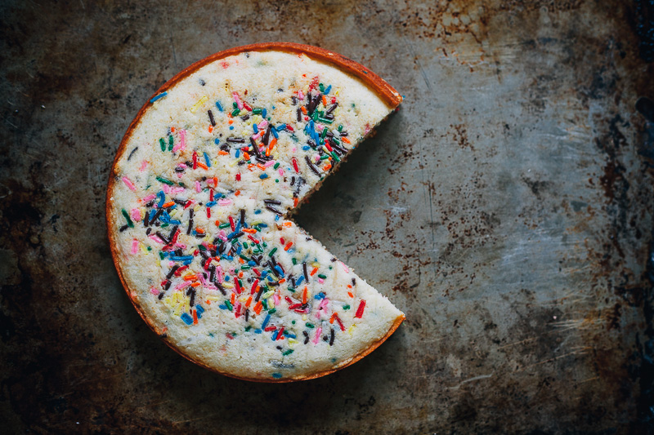

it worked splendidly. the sprinkles were evenly distributed and the cake was flavorful and moist. it had a dense crumb, which i really like, however, boxed cakes are usually much lighter than that, so i wanted to test my luck and try the more-butter option with an all-cake flour mix. (i was trying my best to avoid having to whip the egg whites to peaks because i h8 h8 h8 dirtying up bowls when not necessary.)

annnnd...

*weeeeeeeeeee!!!!!!!!!!!*

light, flavorful, evenly distributed with sprinkles that pop, reminiscent of all of my single digit birthday parties. success.

**final cake, with marzipan bunting:**

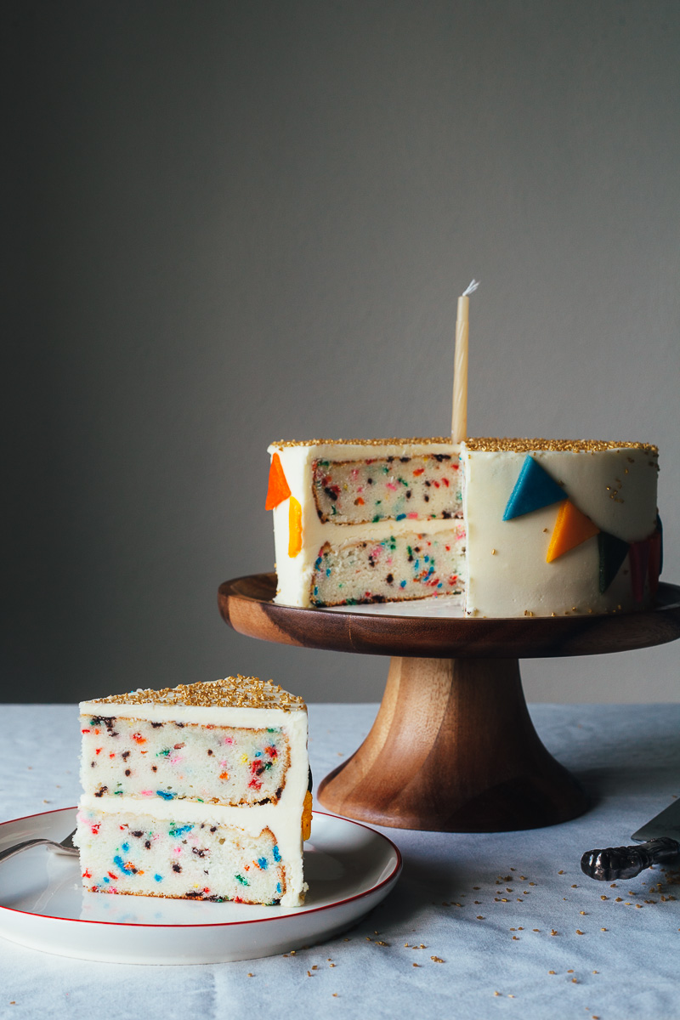

**an update (two years later!)**: i've updated a few things in this recipe! the original recipe is posted over at *food52*, and the updated recipe below is what went in *molly on the range.*a few minor changes: i now prefer to bake this cake in three shorter laters than two tall layers, allowing for a more even frosting distribution which helps more moisture circulate throughout the cake. also with these shorter layers, you now longer need to sprinkle more sprinkles on top of the batter. i've also tweaked the flour situation just a bit to eliminate the need for cake flour. a combination of all-purpose flour and cornstarch gives a most delightful fluffy crumb! (stay tuned for more updates after a million more test runs in what will probably be two more years...)

**sprinkle cake**

*makes one 3-layer 8" cake or 24 cupcakes*

**ingredients**

*for the cake:*

2 1/2 c flour

1/4 c constarch

1 tsp kosher salt

2 tsp baking powder

1 c unsalted butter, at room temperature

1 1/2 c sugar

4 large egg whites

1/4 c flavorless oil

1 tb clear imitation vanilla (I prefer McCormick brand)

1/2 tsp almond extract

3/4 c whole milk

1/2 c rainbow sprinkles (artificially colored cynlinders, not nonpareils, sanding sugar, or anything naturally colored)

*for the frosting:*

1 3/4 c unsalted butter, at room temperature

3 1/2 c powdered sugar

1/8 tsp kosher salt

1 1/2 tsp clear imitation vanilla

1/4 tsp almond extract

2 tb whole milk

*to make the cake:*

1. preheat the oven to 350ºf. grease and line the bottoms of three 8-inch cake pans or line 24 cups of two muffin tins.
2. In a medium bowl, whisk together the flour, cornstarch, salt, and baking powder.
3. In a stand mixer fitted with the paddle attachment, cream together the butter and sugar until light and fluffy, 3 to 4 minutes.
   1. Add the egg whites, one at a time, mixing well after each addition.
   2. Add the oil and the extracts.
4. With the mixer running on low speed, add the dry mixture and the milk in two or three alternating batches and mix until just barely combined.
   1. Using a rubber spatula, gently fold in the sprinkles until they're evenly distributed.
   2. Distribute the batter among the cake pans or muffin cups, spreading it out evenly if using cake pans.
5. Bake until a toothpick inserted into the center comes out clean. Begin checking for doneness at 25 minutes for cakes and 20 minutes for cupcakes.
6. let cool in the pans for 10 minutes and then turn onto a wire rack to cool completely.

*to make the frosting:*

1. In a standing mixer fitted with a paddle attachment, beat the butter until smooth and gradually beat in the powdered sugar. add the salt, extracts, and milk and beat to combine.
2. Frost the cake or cupcakes as desired and enjoy.